STUDENT DETAILS

Student Name: Kariuki Lisper Waigumo

Admission Number: BSCCS/2024/60096

Course/Class: Bachelors of Science in Computer Science

Unit Code: BIT 4139

Unit Name: Ethical Hacking and Counter Measures

Lecturer Name: Michael Nyoro

Semester/ Academic Year: Semester 6

TABLE OF CONTENTS
Table of Contents
Step 1: Download Nmap 2
WEEK 1: INSTALLATION OF NMAP 3
Fig 1: Installing Nmap 4
Fig 2: Nmap step by step installation process 5
Figure 3: Scanning for Vulnerabilities 7
WEEK 3 8
TASK 3: Identifying a company and using the specified tools identify; Domain Register, Email Patterns Used, IP Address 8
Fig 1: Nslookup 8
Figure 2: Ping 9
Figure 3: WHOIS for google.com 10
ASSIGNMENT 2: 11
Title: Scan and Target a specific machine 11
Figure 1: IP CONFIG 11
Figure 2: Check if the host Online 11
Step 3: Scan for Open ports 15
Figure 3: Scan for Open Ports 15
Figure 4: Running Services 16
Figure 5: OS 16
Fig 6: known Vulnerabilities 17
Step 7: Enumerate Shared Resources 18

Step 1: Download Nmap
Visit the official Nmap website:
https://nmap.org/download.html
Download the latest Windows installer.
Step : Run the Installer
- Double-click the installer file
- Accept the license agreement
- Choose installation components
- Complete installation
Step 3: Verify Installation
Open Command Prompt and type:
nmap --version
If installed correctly, the version information will appear.

WEEK 1: INSTALLATION OF NMAP

Fig 1: Installing Nmap
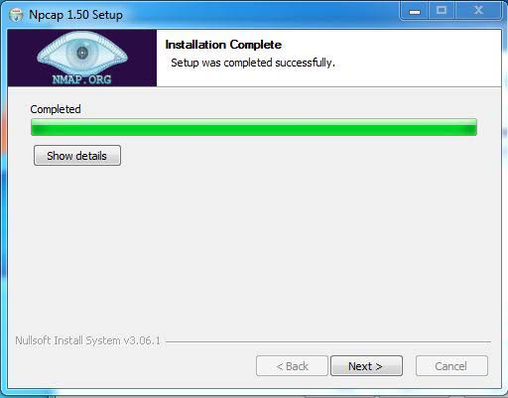

Fig 2: Nmap step by step installation process
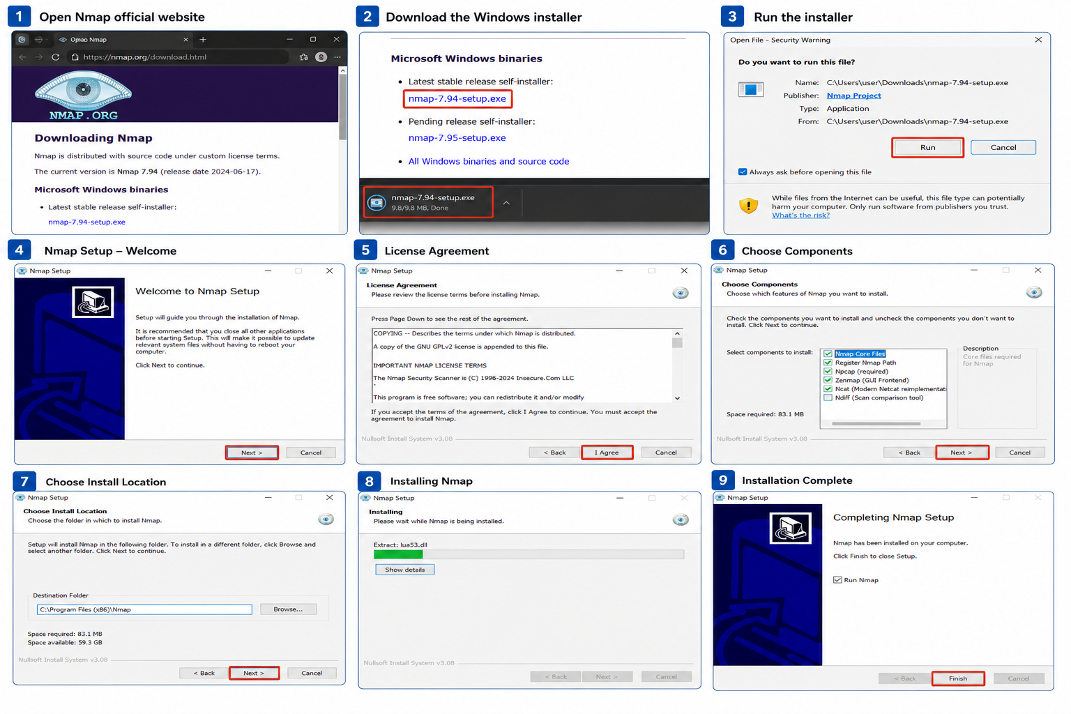
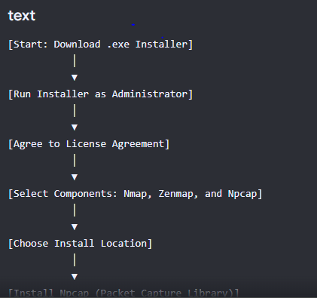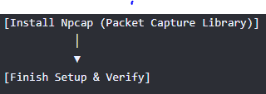

Figure 3: Scanning for Vulnerabilities

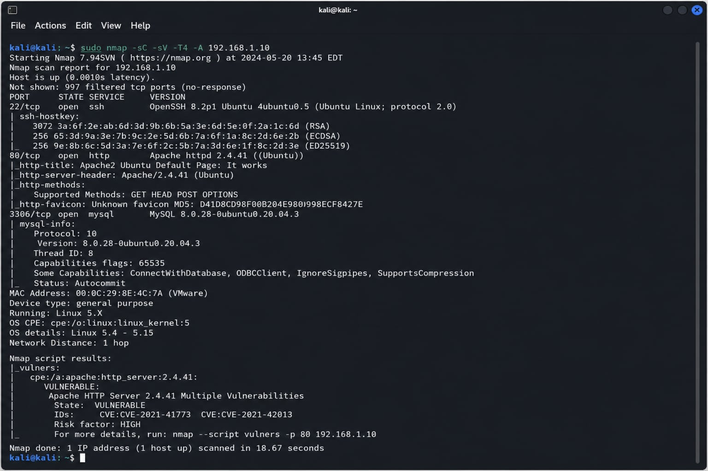

WEEK 3

TASK 3: Identifying a company and using the specified tools identify; Domain Register, Email Patterns Used, IP Address

Fig 1: Nslookup
ff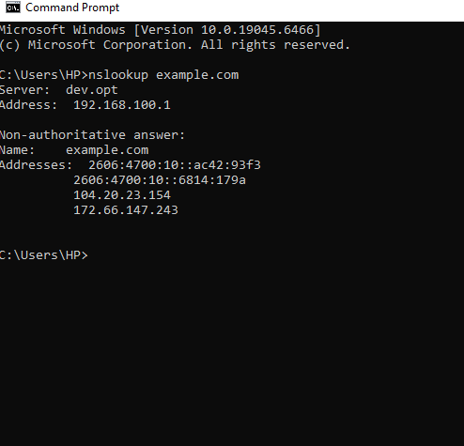

Figure 2: Ping
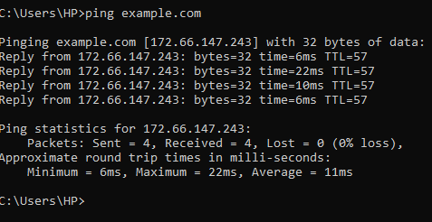

Figure 3: WHOIS for google.com
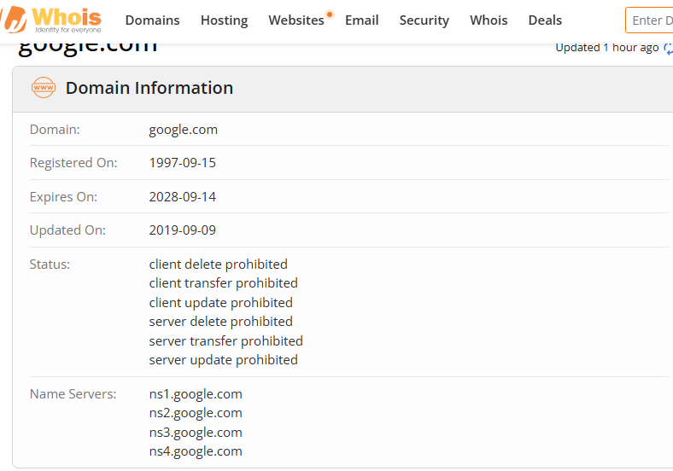

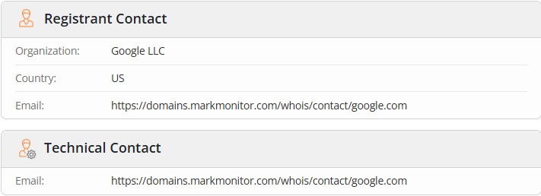

ASSIGNMENT 2:

Title: Scan and Target a specific machine
Step 1: Find the Target IP Address
Figure 1: IP CONFIG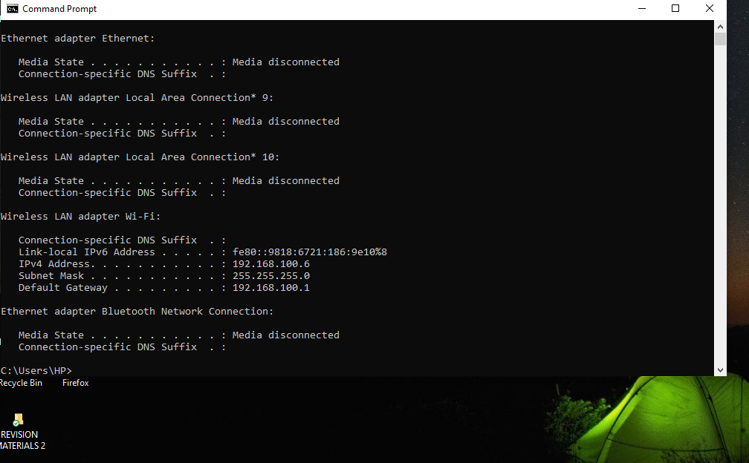

Step 2: Check if the Host is Online
We are going to use Nmap: This verifies that the machine is reachable.

Figure 2: Check if the host Online
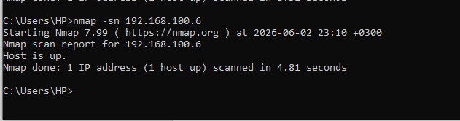

Figure 1:
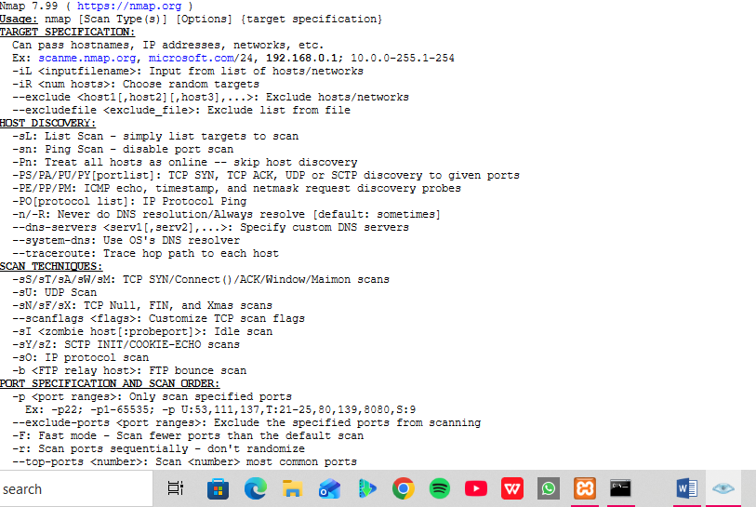
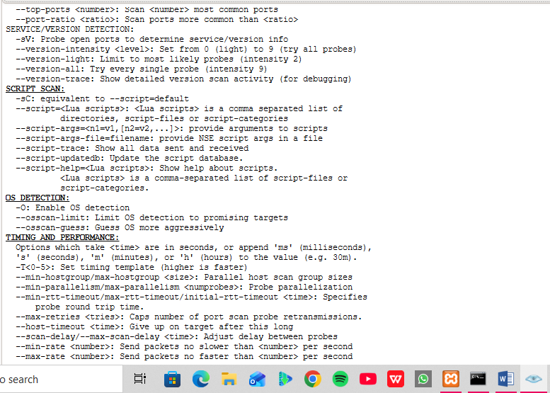

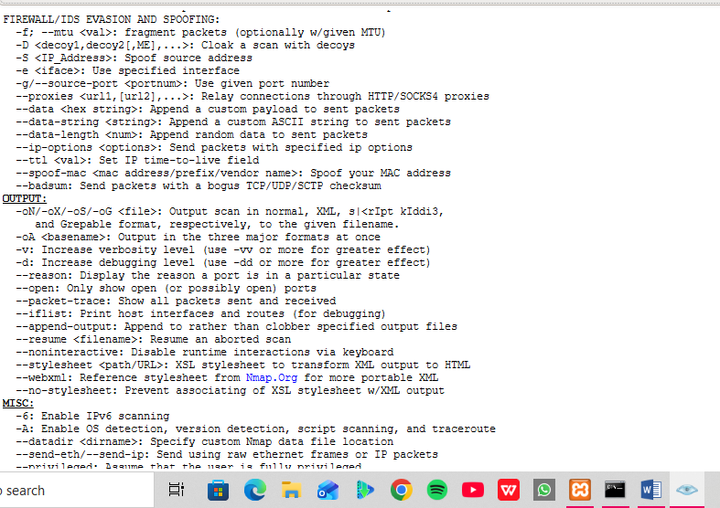

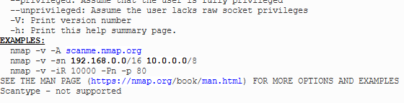

Step 3: Scan for Open ports

Figure 3: Scan for Open Ports
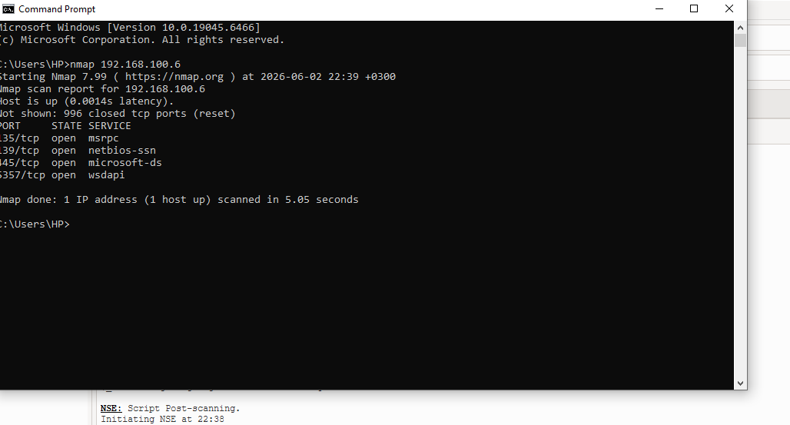

Record: 1. port number
2. Service Name
3.State (open or Closed)

Step 4: Detect Running Services
We will use service detection:

Figure 4: Running Services
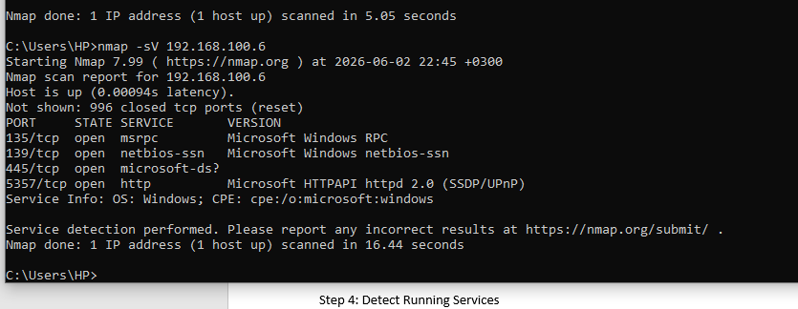
Report: 1. Service Name
2. Version

Step 5: Identify The Operating System (Mine has an issue)

Figure 5: OS
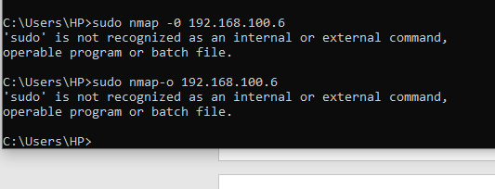
Record: 1. Operating System
2. Version estimate
Step 6: Scan for Known Vulnerabilities
Use Nmap’s vulnerability scripts:

Fig 6: known Vulnerabilities
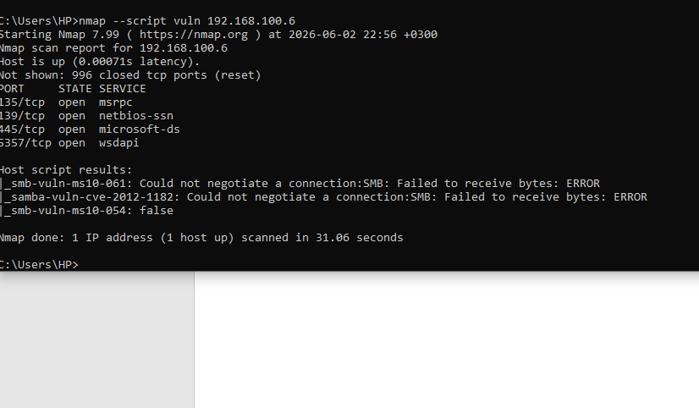

Record: 1. Vulnerabilities detected
2. Severity (if shown)

Step 7: Enumerate Shared Resources
For SMB shares (Windows File Sharing):
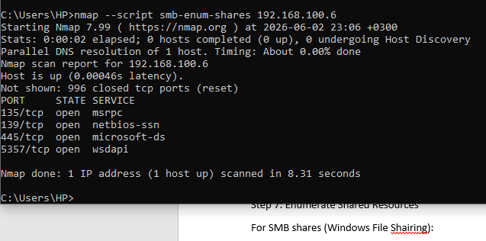

Record: 1. Shared folders found
2. Access Permission

ASSIGNMENT
Task: In a controlled environment test a vulnerable web application for a vulnerabls: Scan for vulnerabilities found, Exploitation methods used, Impact and Mitigation.
Task: Vulnerability Assessment of a vulnerable Web Application Using Nmap
Step 1: Discover the Target
Find the IP address of the vulnerable machine.

